2009 CULTURAL TRIP IN CHINA

For more information, please contact:
East West Exchange
4 Commodore Dr. #442
Emeryville, CA 94608
Phone: (510) 251-0874
E-mail: info@jilijiang.com

If you decided to participate, please print out the forms below and send the following items to the address above by Feb 28, 2009.

- Complete application form with a photo
- Sign “China Tour Features & Condition” form
- $300 deposit payable to: East West Exchange
- If you’d like us to get a visa at Chinese consulate, you need to mail us the following items by May 15, 2009.
    - Chinese visa application form with your signature. (You can download the form at http://houston.china-consulate.org/visa/english/chinese/Q1.pdf)
Here is a sample of answers that you can use as a reference
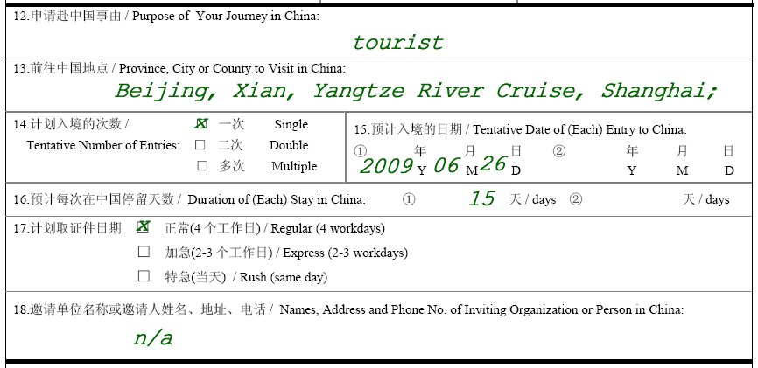
(b) one passport picture (2” x 2”)
(c) your passport (valid for at least six months)
(d) a check of $130 payable to: East West Exchange
APPLICATION FORM

PHOTO
Name: __________________________________________________

Address: ________________________________________________

City: ____________________ State: _______ Zip: __________

Home Phone: (____)_____________ Sex: ______ Age: ________

E-mail ________________________________

Employer: _______________________________________________

Address: ________________________________________________

City: ____________________ State: _____ Zip: __________ Work Phone: (____)___________

EMERGENCY CONTACT:

Name: _________________________ Phone: (___)__________ Relationship: __________

Address: ______________________________________________________________

City: ________________________ State: _____ Zip: _________

Room Preference: Smoking:_____ Nonsmoking:_____ Single Supplement ($600):_____

Departure Airport: 1st choice: __________________ 2nd choice: _____________________

Add a stop in SFO to meet the others? (Air fare might be cheaper to fly directly from your home if

you don’t mind flying to China by yourself)____________________________

Special Needs or Medical Problems: _________________________________________

____________________________________________________________________________________

____________________________________________________________________________________

SIGNATURE _______________________________ DATE ___________________________

CHINA TOUR FEATURES & CONDITION

Tour Price Includes:
China domestic air and ground transportation; 4 star hotels double occupancy; the cruise standard cabin with double occupancy; (Upgrade to suites and deluxe cabins might be available) three meals per day; admission fees for sightseeing and cultural activities; local English speaking tour guide; basic travel insurance.

Does Not Includes:
Round trip international air ticket; visa fees; tips to tour guides and drivers; excess baggage charges; single room supplement if required; all items of a personal nature including laundry, bottled water, liquor, telephone, mail, room service, medical expenses, cancellation and additional insurance.

Responsibilities:
The organizers act only in the capacity of an agent in making arrangements for transportation, hotel accommodation and other services. All tickets, exchange orders or vouchers issued by them are subject to the terms and conditions under which such means of transportation, accommodations or other services are offered or provided. The organizers shall not be held liable or responsible for any expenses, loss, injury, damage, death, of whatsoever nature arising from the use of any conveyance, accommodations, or services, or from acts of God, fire, war, strikes, weather, or other force majeure. No responsibility is accepted for any damage or delay due to government regulation, and insufficient or improperly issued passports, visa or other documents, or any causes beyond the organizers’ control. Neither the organizers shall be liable or responsible for any loss, damage or penalty resulting from participant’s violation of the laws and regulations of PRC. The organizers reserve the right to adjust the itinerary or to substitute hotels due to local conditions. Neither airlines nor public transportation companies concerned are to be held responsible for any act, omission or event during the time passengers are not on board their aircraft or conveyances.

Deposit & Final Payment:
Deposit: $300 per person by Feb 28, 2009
Final payment: Must be received 60 days prior to the departure date

Refunds & Cancellations
Refund policy will be applied from the date of receipt of the written cancellation.
60 days or more prior to departure ------------------ charge $50 per person handling fee
21 days to 60 days prior to departure --------------- charge $500 per person
1 day to 20 days prior to departure ----------------- charge $1000 per person
On or after departure date -----------------------------No refunds

NOTE: The organizers reserve the right to cancel any trip when the group size falls below 15 people. You will get a full refund and join the next trip at a discount rate.

Refund on unused tour arrangements:
No refund or exchange will be allowed for any missed or unused hotel accommodations, meals, ground transportation or any other services for which the organizers cannot receive a refund.

SIGNATURE __________________________ DATE ________________

PRINT NAME _________________________ DATE ________________

